**CONTACT BOOK**

Project submitted to the

SRM University – AP, Andhra Pradesh

for the partial fulfillment of the requirements to award the degree of

## Bachelor of Technology/Master of Technology

In

## Computer Science and Engineering School of Engineering and Sciences

Submitted by

## Candidate Name

## AP21110010134

## AP21110010132

## AP21110010178

## AP21110010179



Under the Guidance of

## POONAM YADAV

**SRM University–AP**

**Neerukonda, Mangalagiri, Guntur Andhra Pradesh – 522 240**

**[DEC, 2022]**

# Certificate

Date: 12/6/2022

This is to certify that the work present in this Project entitled “**CONTACT BOOK**” has been carried out by **[**Vishnupriya**]** under my/our supervision. The work is genuine, original, and suitable for submission to the SRM University – AP for the award of Bachelor of Technology/Master of Technology in **School of Engineering and Sciences**.

## Supervisor

(Signature)

Prof. / Dr. [ Poonam yadav] Designation,

Affiliation.

## Co-supervisor

(Signature)

Prof. / Dr. [Name] Designation,

Affiliation.

# Certificate

Date: 12/6/2022

This is to certify that the work present in this Project entitled “**CONTACT BOOK**” has been carried out by **[**,harika**]** under my/our supervision. The work is genuine, original, and suitable for submission to the SRM University – AP for the award of Bachelor of Technology/Master of Technology in **School of Engineering and Sciences**.

## Supervisor

(Signature)

Prof. / Dr. [ Poonam yadav] Designation,

Affiliation.

## Co-supervisor

(Signature)

Prof. / Dr. [Name] Designation,

Affiliation.

# Certificate

Date: 12/6/2022

This is to certify that the work present in this Project entitled “**CONTACT BOOK**” has been carried out by **[**nandini**]** under my/our supervision. The work is genuine, original, and suitable for submission to the SRM University – AP for the award of Bachelor of Technology/Master of Technology in **School of Engineering and Sciences**.

## Supervisor

(Signature)

Prof. / Dr. [ Poonam yadav] Designation,

Affiliation.

## Co-supervisor

(Signature)

Prof. / Dr. [Name] Designation,

Affiliation.

# Certificate

Date: 12/6/2022

This is to certify that the work present in this Project entitled “**CONTACT BOOK**” has been carried out by[varshita]under my/our supervision. The work is genuine, original, and suitable for submission to the SRM University – AP for the award of Bachelor of Technology/Master of Technology in **School of Engineering and Sciences**.

## Supervisor

(Signature)

Prof. / Dr. [ Poonam yadav] Designation,

Affiliation.

## Co-supervisor

(Signature)

Prof. / Dr. [Name] Designation,

Affiliation.

# Table of Contents

Certificate 2

Table Contents 3

Abstract 4

List of Tables 5

List of Figures  7

List of Equations 9

1. Introduction

1.1.project objective

* + 1. Purpose

1.1.2 scope

1. Methodology 12
   1. Requirement specification

2.2 functional requirement

2.3 Code

2.4 Output

2.5 Output Documentation

3 Concluding Remarks 20

4 References 21

# Abstract

# 

# Contact book system is small web application developed for projects in older days we stored our important contact details in books and papers here we proposed a new system using this application we can store all details

# In manual method if we forget information book then it very difficult to get the contact details by using this application we can see our contacts any where in the world,here we have security to the login page and no one can see our contacts with out prop authentication In this project we can save our contacts, address and we can search them by name and also , we can see all them at a time.

# This system is developed using the general required by the user while using the contact book in order to keep updated the contact book directory, the admin will have the authority to add id and delete as well as modify the existing records within the contact book theuser will only have the authority to search any particular and listing details of available records

# The contact book application works specifically for tracking people. The contact book application contains a set of basic functions for adding, searching, updating, and deleting new contacts. This mini-C contact book design allows you to perform simple tasks in your contact book, such h as mobile phones. You can add text to the contact book, find, edit, search, and delete. The concept of file management and data structure is often used in almost all functions in this project.  It uses functions, file management, and data structure.

# This application provides information on adding, viewing, modifying, receiving, and deleting data from/to files. Adding new entries, browsing them, editing and updating, searching for saved contacts, and deleting contacts in the contact book is one of the most important services that become the main menu in the contact book application. When you add anything to your contact book, you will be asked for personal information such as name, gender, first name, phone number, nationality, email address, and address. You can then edit, view, search, and delete this text.

# List of Tables :

# Table 01

Adding contact:

|  |  |  |
| --- | --- | --- |
| FIELD_NAME | DATA_TYPE | DESCRIPTION |
| num | Int | It show how many numbers to add |
| Contact_name | Varchar | It show Contact Name |
| Mobile Number | Varchar | It show Mobile Number |

Table 02:

Search contact:

|  |  |  |
| --- | --- | --- |
| FIELD_NAME | DATA_TYPE | DESCRIPTION |
| Search term | Int | It searches name,term,number |
| Contact_name | Varchar | It show Contact Name |
| Mobile Number | Varchar | It show Mobile Number |

Table o3:

Modify contact:

|  |  |  |
| --- | --- | --- |
| FIELD_NAME | DATA_TYPE | DESCRIPTION |
| Search_t | Int | It searches that you want to modify |
| Contact_name | Varchar | It show Contact Name |
| Mobile Number | Varchar | It show Mobile Number |
| Update Number | Varchar | It show updated number |
| Update name | Varchar | It shows updated name |

Table 04:

Delete contact:

|  |  |  |
| --- | --- | --- |
| FIELD_NAME | DATA_TYPE | DESCRIPTION |
| Delete term | Int | It shows the deleted you want to do in cotact |
| Contact_name | Varchar | It show Contact Name |
| Mobile Number | Varchar | It show Mobile Number |

# List of Figures

Figure 1. **Entity Relationship Diagram:**

An ER model is an abstract way of describing a [database](http://en.wikipedia.org/wiki/Database). In the case of a [relational database](http://en.wikipedia.org/wiki/Relational_database), which stores data in tables, some of the data in these tables point to data in other tables - for instance, your entry in the database could point to several entries for each of the phone numbers that are yours. The ER model would say that you are an entity, and each phone number is an entity, and the relationship between you and the phone numbers is 'has a phone number'. Diagrams created to design these entities and relationships are called entity–relationship diagrams or ER diagrams.

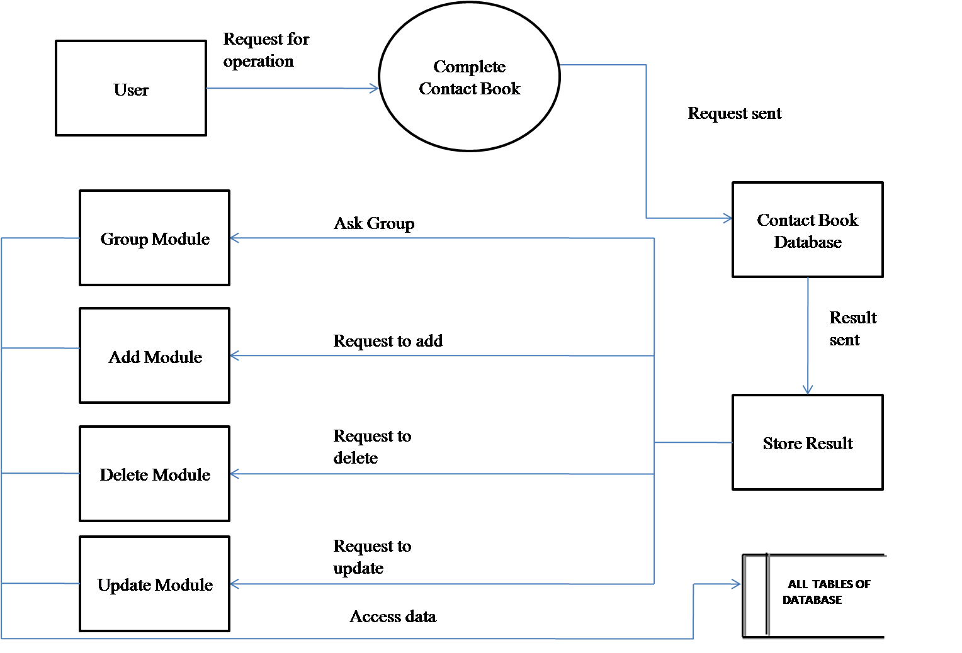

**Figure:2**

**Procedural Design:-**

**Logic Diagrams**: A **flowchart** is a type of [diagram](http://en.wikipedia.org/wiki/Diagram) that represents an [algorithm](http://en.wikipedia.org/wiki/Algorithm) or [process](http://en.wikipedia.org/wiki/Process_(science)), showing the steps as boxes of various kinds, and their order by connecting them with arrows

Start

Admin login

Main page

Choose operation

Add page

Add to database

Delete page

Deletes from database

Search Page

Search from

database

Update

page

Update in database

# List of Equations

# 1.Introduction

Complete Contact Book is an application based project. It is designed for people to store the information about their contacts. Rather than going through the pages of their diaries and copies to search a person information, a person can simply use this software to view any of his stored contacts. A user can also add or update or delete the contact information according to his need. Big Organizations need to have this software in order to keep the records of thousands of his employees at one place without any paper work. Also registers maintained for this purpose can be left around, or can be destroyed in any accident, but in software no such problem will occur This software also provides an option to connect to facebook , it also provides the report , you can also view people through various groups.

* 1. **Project Objective**

For easy and convenient processing we need to develop software which works as per our requirements. While preparing this software we got to remember few things i.e. this software must have a friendly environment, in other words it should not be much complicated to handle, it should have options for future modifications in the society. For smooth functioning, we had to prepare a database by which we could enter the required data in their respective locations. In this data base all the records of daily transactions made are stored i.e. Contact Details , so that we can use them in future whenever needed. From security point of view this software has a special login name and password allotted to their Administrator. Other than that no one could use this and on entering an illegal password or login name an error message get displayed.

The major specifications of project are:

* To allow only authorized user to access various function and processed available in the system.
* Locate any Contact wanted by the user.
* Reduced written work and problem of storing the diaries as most of the work done by computer.
* Provide greater speed & reduced time consumption

1.1.1 **Purpose :**

The overall purpose of this project is to develop a Visual Basic .net which will provide an interface between controls applications written in the VB.net language and the MYSQL Server Management. One aspect of this work will be to develop a language independent object-oriented model to the accelerator devices.

Contact Book will have the following key goals:

* Provide an easy interface for user.
* Easy to store records
* No need to remember while storing that on what page we are storing as software will automatically search the name you enter
* Updation can be done.
* Deletion can also be done when you do not need a contact.
* You can search a contact through his/her name , part of name, or through id.
* You can view group of people according to various options like group of people of same address or group of people of same company etc.
* Reports can be viewed to show an abstract form of contact book containing all the contacts together at one place
* Reports can be converted as a pdf file to store as a shortcut, no need to run the software again and again
* User can automatically connect themselves to social media site
* User can give all suggestions they need and can save their files.

1.1.2 **Scope:**

The main scope and deliverables of the project would be to:

* Understand and prepare detailed user requirement and specifications
* Prepare high level and detailed design specifications of the system
* Prepare Test Plan & Test cases
* Develop the system and coding
* Perform unit testing, integration testing and system testing
* Demonstrate a bug free application after suitable modification, if needed

# Methodology

2.1 **Requirements Specification**

* User Requirements:-

A careful study of the requirement of the end user; i.e. the Contact Book should meet the following requirements:

* User should be able to add image for his contact
* No User without the correct login and password may be allowed to enter the project
* User should be provided with an option to add the record just by adding the fields value.
* User could be able to delete any record he/she wants.
* User should be able to search a record either by entering name or part of name or by choosing groups.
* User should be able to update the record.
* User should be able to connect to facebook.
* User should be able to see the records in a file and in report also.
* Although the system is to be installed in a low end system with Windows based OS at present, in future it should be portable to a higher end system with Linux OS
* The system should have a relatively lower memory and bandwidth requirement

2.2 **Functional Requirements:-**

The Functional Requirements of the project are as follows:

* To provide the functionality to person to view details of contact.
* To provide login interface through which only authorized user can pass by.
* The  application provide contact the option to add the photo from any file in its pc..
* This system should handle multiple contacts at the same time.
* To functionally enable Contacts define criteria and create Admin.
* The application also provides an option to view group belonging to a person.

Functions and its definitions in program:

def add(self): which add contact numbers

def search(self): which search the contact

def modify(self):which modify the contact name,number

def delete(self): which deletes the contact

def display(self):which displays the contact

**2.3 Code:-**

class use :

def __init__(self,names,phone_numbers,num):

self.phone_numbers=phone_numbers

self.names=names

self.num=num

###############################################################################################################################

def add(self):

num=int(input("Enter how many numbers you want to add in the book : "))

for i in range(num):

name = input("Enter Name: ")

phone_number = input("Enter Phone Number: ")

print("\n")

names.append(name)

phone_numbers.append(phone_number)

print("Contact saved sucessfully !\n\n")

#################################################################################################################################

def search(self):

search_term = input("\nEnter search term: ")

print("Search result:")

if search_term in names:

index = names.index(search_term)

phone_number = phone_numbers[index]

print("Contact Found !!\n")

print("Name: {}, Phone Number: {}\n\n".format(search_term, phone_number))

else:

print("Name Not Found, Try again\n")

##################################################################################################################

def modify(self):

search_t= input("\nEnter the name for modifying: ")

ind=0

if search_t in names:

ind = names.index(search_t)

else :

print("Contact not found, Please try again")

loc=ind

print("Enter the following options")

print("1.Update name\n2.Update Number\n")

c=int(input("Enter your choice :"))

if c==1 :

str1=str(input("Enter Name :"))

names[loc]=str1

else :

str2=int(input("Enter number :"))

phone_numbers[loc]=str2

#####################################################################################################################################################

def delete(self):

delete_term = input("\nEnter delete term: ")

print("\n")

if delete_term in names:

index = names.index(delete_term)

names.remove(delete_term)

phone_number = phone_numbers[index]

phone_numbers.remove(phone_number)

print("Contact Deleted sucessfully !!\n")

else:

print("Name Not Found, Try again\n")

#####################################################################################################################################################

def display(self):

if len(names)==0:

print("No Contacts Found\n")

else :

print("\nHere is the result\n")

print("\nName\t\t\tPhone Number\n")

for i in range(len(names)):

print("{}\t\t\t{}".format(names[i], phone_numbers[i]))

print("\n")

##################################################################################################################################################################

print("********* Welcome to Telephone Directory Book *********")

names = []

phone_numbers = []

num=0

u=use(names,phone_numbers,num)

a=1

while a:

print("Select the following operations")

print("1.Add a number\n2.Search a number\n3.Modify a number\n4.Delete a number\n5.Display contacts")

option=int(input("Enter your choice :"))

if(option==1):

u.add()

elif(option==2):

u.search()

elif(option==3):

u.modify()

elif (option==4):

u.delete()

elif(option==5):

u.display()

else :

print("Invalid Option, Please choose the correct option again")

a=int(input("Do want to continue ?, If yes press 1 or else press 0 :"))

print("\n")

print("******** Thank You **********")

**2.4 Output:**

********* Welcome to Telephone Directory Book *********

Select the following operations

1.Add a number

2.Search a number

3.Modify a number

4.Delete a number

5.Display contacts

Enter your choice :1

Enter how many numbers you want to add in the book : 2

Enter Name: res

Enter Phone Number: 54322222

Contact saved sucessfully !

Enter Name: sis

Enter Phone Number: 756633899

Contact saved sucessfully !

Do want to continue ?, If yes press 1 or else press 0 :1

Select the following operations

1.Add a number

2.Search a number

3.Modify a number

4.Delete a number

5.Display contacts

Enter your choice :2

Enter search term: sis

Search result:

Contact Found !!

Name: sis, Phone Number: 756633899

Do want to continue ?, If yes press 1 or else press 0 :1

Select the following operations

1.Add a number

2.Search a number

3.Modify a number

4.Delete a number

5.Display contacts

Enter your choice :3

Enter the name for modifying: sis

Enter the following options

1.Update name

2.Update Number

Enter your choice :1

Enter Name :sister

Do want to continue ?, If yes press 1 or else press 0 :1

Select the following operations

1.Add a number

2.Search a number

3.Modify a number

4.Delete a number

5.Display contacts

Enter your choice :5

Here is the result

Name Phone Number

res 54322222

sister 756633899

Do want to continue ?, If yes press 1 or else press 0 :0

******** Thank You **********

>

2.5 Output Documetation:

Figure 2.5.1:- adding contacts to contact book

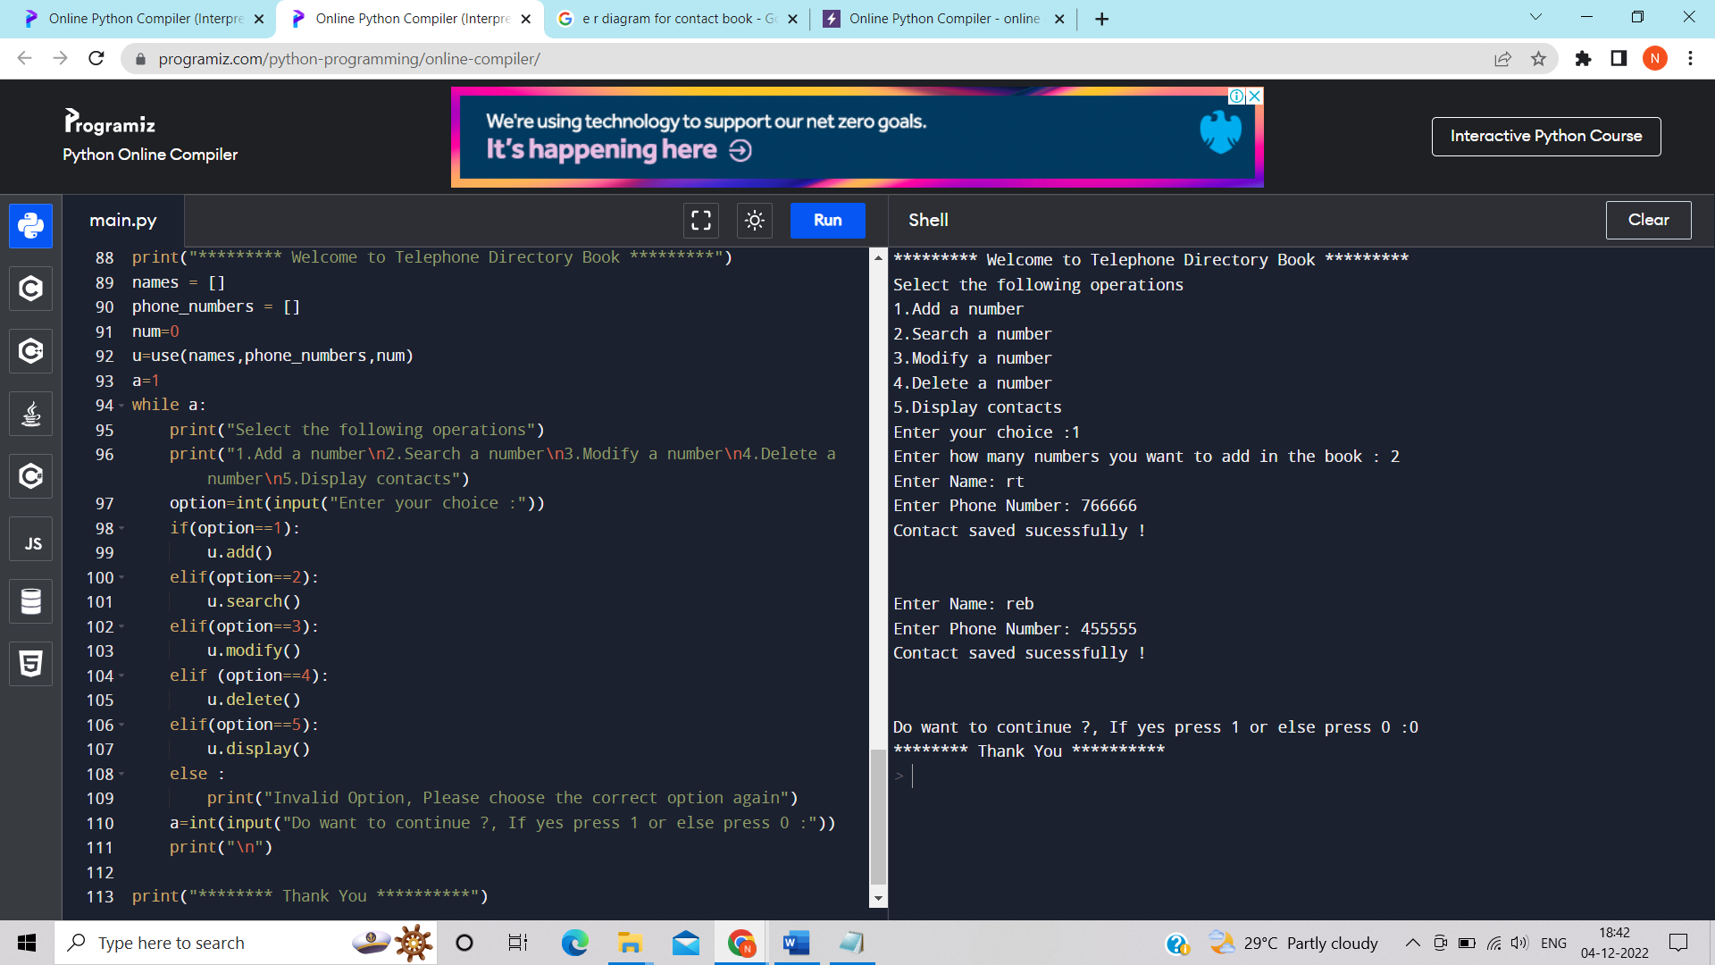

Figure 2.5.2 searching contact in contact book:-

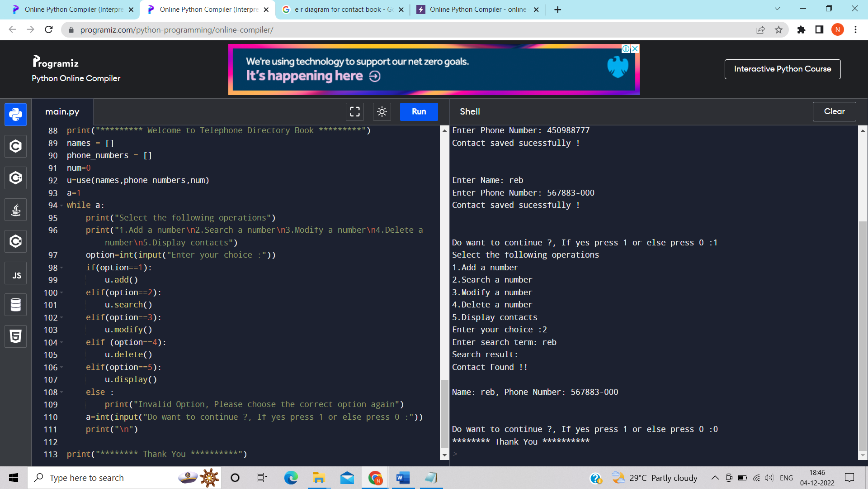

Figure 2.5.3 modyfying a contact:-

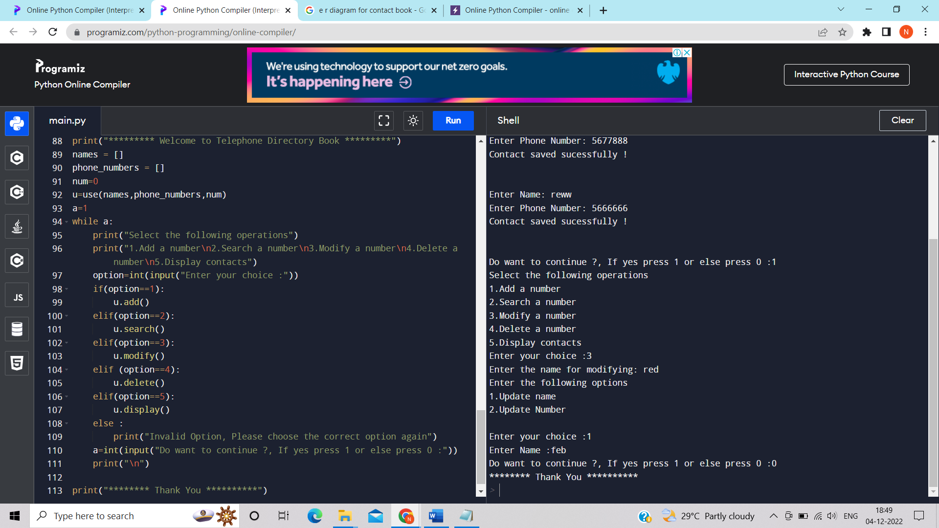

Figure 2.5.4 :displaying contact

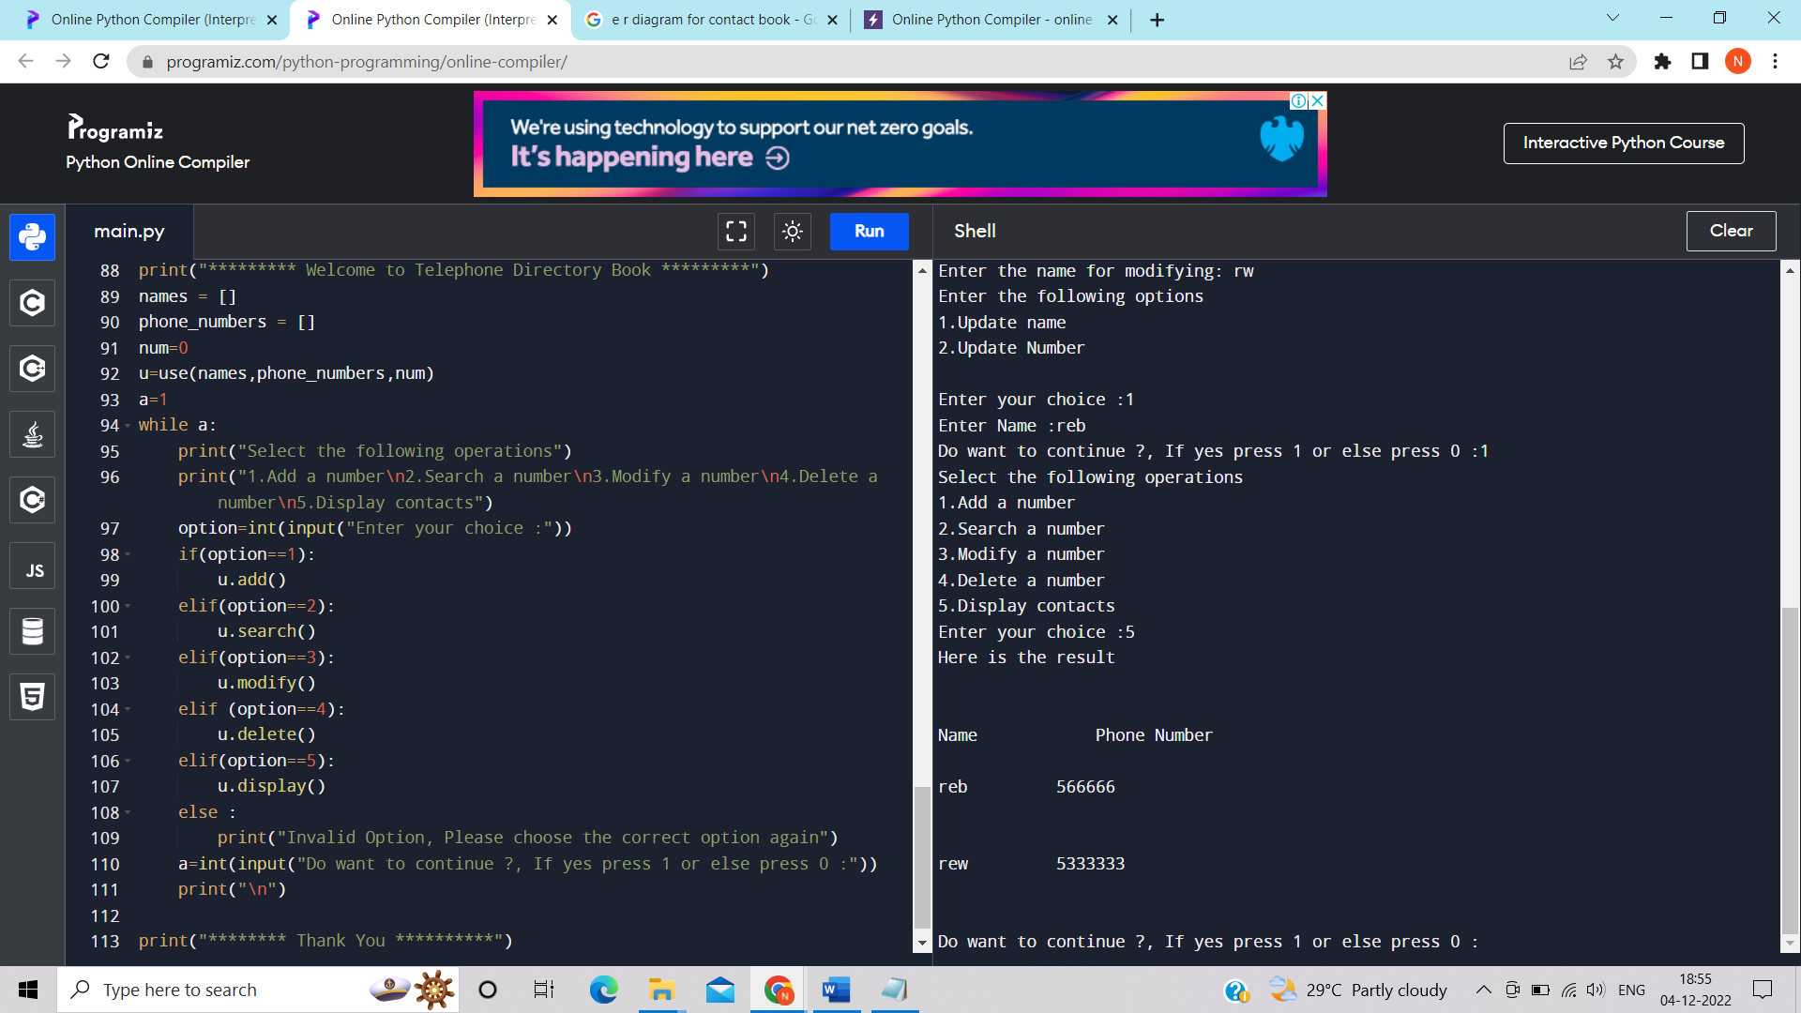

# 3.Conclusion:

Building a contact book application with Python is an excellent exercise for you to expand your skills with these tools and as a developer in general. Coding projects like this allows you to apply the knowledge and skills you already have and also pushes you to research and learn about new topics every time you encounter a new programming problem.

This application software has been computed successfully.it is very useful and our projects shows the purpose and scope of contact book.it really saves our time instead searching somewhere in diary.

Hence,our project gone through so many test cases and passed everything needed.

# 

# References:-

# <https://www.programiz.com/python-programming/online-compiler/>

# https://scribemedia.com/write-book-conclusion/

# https://realpython.com/python-contact-book/

# https://www.coursehero.com/file/44015997/PHONE-BOOK-final-last/